SIMATS ENGINEERING
CO3 - ASSESSMENT TOOL 3
Comparative Analysis
COURSE NAME: DEEP LEARNING COURSE CODE: MLA0408
COURSE OUTCOME COVERED
CO3: Students will be able to understand, analyze and apply CNN concepts including layers, filters, parameter sharing, regularization, AlexNet and ResNet for real-world image processing applications. (BTL-6)
CO Weightage: 25%
Assessment Tool Weightage: 40%
QUESTIONS: Total Marks:25
Q1. CNN vs Fully Connected Neural Network
A medical imaging organization wants to classify X-ray images using deep learning. Compare a CNN with a traditional fully connected neural network in terms of architectural design, motivation, spatial feature extraction, number of parameters, computational complexity, and ability to handle image data. Analyze the roles of convolutional layers, filters, and pooling layers, and justify why CNNs are more suitable for image classification applications.
Q2. Different CNN Layers and Filters
A manufacturing company is developing a CNN-based system to detect defects in industrial products. Compare the functions of convolutional layers, pooling layers, activation layers, and fully connected layers in terms of feature extraction, spatial information, computational requirements, and classification. Further compare early-layer filters and deeper-layer filters based on the type of features they learn, and justify how these layers collectively improve defect detection.
Q3. Parameter Sharing vs Independent Weights
A smart surveillance system needs to process thousands of high-resolution images efficiently. Compare parameter sharing in CNNs with independent weights in fully connected networks in terms of the number of parameters, memory requirements, computational complexity, feature detection, and translation-related invariance. Analyze how the reuse of convolutional filter weights improves learning efficiency and justify its importance for largescale image-processing applications.
Q4. AlexNet vs ResNet
A computer vision company is developing an image classification system and is considering AlexNet and ResNet as possible architectures. Compare the two architectures in terms of network depth, layer organization, convolutional filters, parameter requirements, feature extraction capability, training difficulty, vanishing-gradient problem, computational cost, and classification performance. Recommend the more suitable architecture for a complex image recognition application and justify your choice.
Q5. Regularized CNN vs Non-Regularized CNN
An agricultural organization is developing a CNN to classify plant diseases from leaf images. The initial model achieves very high training accuracy but performs poorly on unseen images. Compare a CNN without regularization and a CNN using dropout, data augmentation, and batch normalization in terms of overfitting, generalization, training stability, computational requirements, and model performance. Analyze which regularization techniques should be applied and justify the most appropriate approach for reliable real-world disease classification.
Code of Conduct:
I ____________________ (Name / Reg No) certify that this submission is my original work and that I have adhered to the guidelines specified for this assessment.
I understand that any violation of academic integrity rules will result in disciplinary action.
Signature of the student:
RUBRICS FOR CALCULATION:
Criteria | Weightage | Level 4 –  Exemplary | Level 3 –  Proficient | Level 2 –  Developing | Level 1 –  Beginning
Selection of  Studies/Parameters | 20% | Selects highly relevant and diverse studies with well-defined comparison parameters | Selects relevant studies with minor gaps in parameter definition | Limited or partially relevant selection | Poor or inappropriate selection of studies
Comparison &  Differentiation | 25% | Clearly compares multiple aspects (methods, results, limitations) with strong differentiation | Good comparison with minor gaps | Basic comparison with limited depth | No clear comparison; mostly descriptive
Critical Evaluation | 25% | Critically evaluates strengths, weaknesses, and implications with strong justification | Provides evaluation with some justification | Limited evaluation; lacks depth | No critical evaluation provided
Synthesis & Insight  Generation | 20% | Generates meaningful insights and conclusions from comparisons | Some  insights derived from comparison | Limited or unclear insights | No insights generated
Clarity | 10% | Information is clearly presented (tables/figures) with logical structure | Generally clear with minor issues | Presentation lacks clarity or structure | Poor presentation and difficult to understand

Q1. CNN vs Fully Connected Neural Network
A Convolutional Neural Network (CNN) is more suitable for X-ray image classification than a traditional Fully Connected Neural Network (FCNN) because CNNs are specifically designed to process spatial data such as images.
Aspect | CNN | Fully Connected Neural Network
Architectural design | Uses convolution, activation, pooling and fully connected layers | Mainly consists of fully connected layers
Motivation | Designed to preserve and learn spatial relationships in images | Designed mainly for general numerical/vector data
Spatial feature extraction | Automatically detects edges, textures, shapes and objects | Loses much of the spatial relationship after flattening the image
Number of parameters | Fewer because filters are shared across locations | Very large because every input connects to every neuron
Computational complexity | More efficient for images due to local connections and parameter sharing | Computationally expensive for high-resolution images
Image handling | Directly handles image structure | Usually requires flattening the image into a vector
Feature learning | Learns hierarchical visual features automatically | Learns features but without strong spatial awareness

Roles of CNN Components
1. Convolutional layers:
Convolutional layers apply small filters to different regions of an X-ray image. They detect important features such as edges, textures, boundaries and abnormal regions.
2. Filters:
Filters contain learnable weights. Different filters learn different patterns. Early filters may
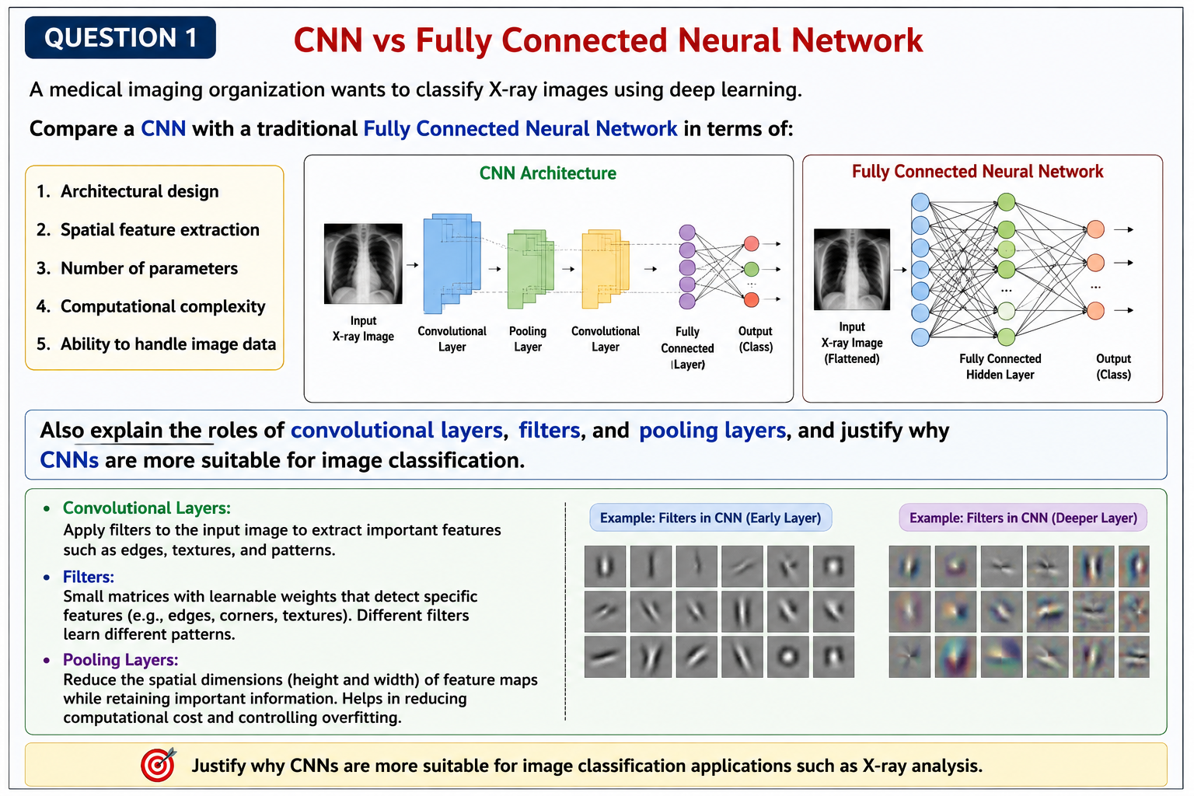
detect simple edges, while deeper filters can identify complex structures and disease-related patterns.
3. Pooling layers:
Pooling reduces the spatial dimensions of feature maps. It decreases computational requirements while retaining important features. Max pooling, for example, selects the strongest feature from a small region.
4. Fully connected layers:
After feature extraction, fully connected layers combine the learned features and perform the final classification, such as Normal or Disease-Affected.

Conclusion
CNNs are more suitable for X-ray classification because they preserve spatial information, require fewer parameters through parameter sharing, automatically learn hierarchical features, and efficiently process high-dimensional images. Therefore, CNNs generally provide better performance and scalability for medical image classification.

Q2. Different CNN Layers and Filters
A CNN-based industrial defect detection system uses different layers for different stages of processing.
Layer | Main Function | Spatial Information | Computational Requirement | Role in Classification
Convolutional layer | Extracts visual features | Preserves spatial relationships | Moderate | Provides feature maps
Pooling layer | Reduces feature-map size | Partially preserves important information | Low | Makes features compact
Activation layer | Introduces non-linearity | Maintains feature-map structure | Low | Helps learn complex patterns
Fully connected layer | Combines extracted features | Spatial information is largely flattened | High compared with pooling | Produces final classification

1. Convolutional Layers
Convolutional layers scan the product image using filters. They identify important patterns such as cracks, scratches, holes, irregular edges and surface abnormalities.

2. Pooling Layers
Pooling reduces the height and width of feature maps. This decreases the number of computations and makes the model less sensitive to small changes in the position of a defect.

3. Activation Layers
Activation functions such as ReLU introduce non-linearity. Without activation functions, multiple layers would behave like a simple linear transformation and would not be able to learn complex defect patterns.

4. Fully Connected Layers
Fully connected layers receive the extracted high-level features and use them to classify the product, for example:
- Defective
- Non-defective
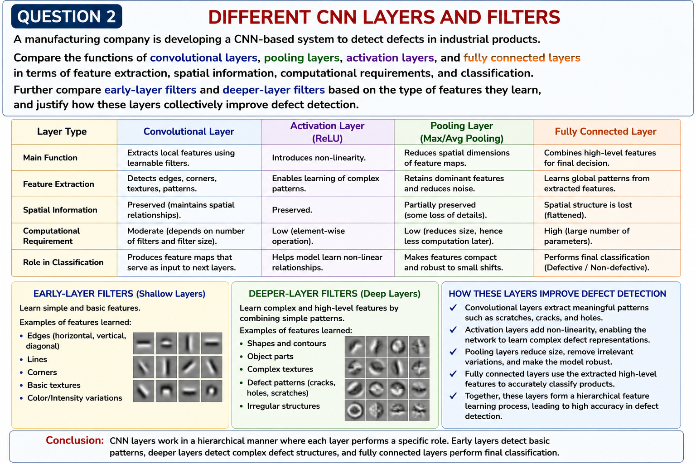

Early-Layer vs Deeper-Layer Filters
Early-layer filters generally learn simple features such as:
- Horizontal edges
- Vertical edges
- Diagonal edges
- Basic textures
- Simple color or intensity patterns
Deeper-layer filters combine these simple features to learn more complex patterns such as:
- Shapes
- Object parts
- Complex textures
- Crack patterns
- Surface defects

Conclusion
The layers work together hierarchically. Convolutional layers extract features, activation layers enable complex learning, pooling reduces dimensions, and fully connected layers perform classification. Early filters detect basic patterns while deeper filters detect complex defect structures. This combination makes CNNs highly effective for automated industrial defect detection.
Q3. Parameter Sharing vs Independent Weights
Parameter sharing is one of the most important advantages of CNNs for large-scale image processing.
Aspect | CNN with Parameter Sharing | Fully Connected Network with Independent Weights
Parameters | Relatively fewer | Very large
Memory requirement | Lower | Higher
Computational complexity | More efficient | Computationally expensive
Feature detection | Same filter detects a feature at different locations | Separate weights are learned for different input connections
Spatial structure | Preserved | Mostly lost after flattening
Translation handling | More robust to feature movement | Less effective
Learning efficiency | High | Lower for large images

Parameter Sharing in CNNs
A CNN uses the same filter weights across different spatial locations. For example, if a filter learns to detect a vertical edge, the same filter can detect that edge whether it appears on the left, center or right side of an image.
Therefore, the network does not need a separate set of weights for every image location.

Independent Weights in Fully Connected Networks
In a fully connected network, every input pixel is connected independently to neurons. For a high-resolution image, this can produce millions of parameters.
For example, a flattened 224 × 224 RGB image contains:
224 × 224 × 3 = 150,528 input values.
Connecting these to only 1,000 neurons would require approximately:
150,528 × 1,000 = 150.5 million weights, excluding biases.
A CNN can perform feature extraction with dramatically fewer parameters because the same filters are reused.

Translation-Related Advantage
Parameter sharing allows a CNN to recognize the same feature at different positions. Pooling further provides a degree of translation tolerance by reducing sensitivity to small positional changes.
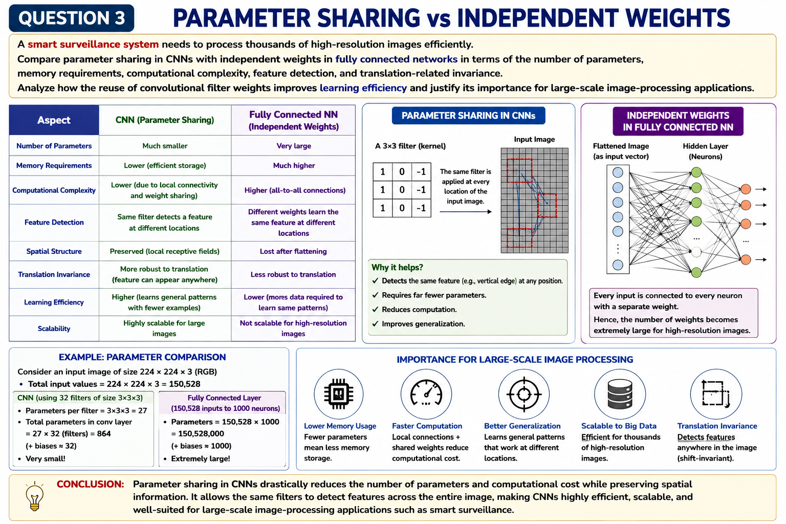

Importance for Large-Scale Image Processing
For thousands of high-resolution surveillance images, parameter sharing:
- Reduces memory usage.
- Reduces the number of trainable parameters.
- Improves computational efficiency.
- Allows faster learning.
- Reduces the risk of overfitting.
- Enables detection of the same feature at different locations.

Conclusion
CNN parameter sharing is essential for large-scale image processing because it provides efficient feature detection with substantially fewer parameters. This makes CNNs much more practical than fully connected networks for high-resolution surveillance applications.
Q4. AlexNet vs ResNet
AlexNet and ResNet are important CNN architectures, but ResNet is generally more suitable for complex modern image-recognition applications.
Aspect | AlexNet | ResNet
Network depth | Relatively shallow, about 8 learned layers | Can have 18, 34, 50, 101, 152 or more layers
Layer organization | Convolutional and fully connected layers | Convolutional layers organized mainly into residual blocks
Convolutional filters | Uses progressively deeper feature extraction | Uses convolutional filters within residual blocks
Parameters | About 60 million in the original model | Depends on version; ResNet-50 has about 25.6 million
Feature extraction | Learns low- to high-level visual features | Learns much deeper and more complex hierarchical features
Training difficulty | Easier than very deep networks | Skip connections make deep training easier
Vanishing-gradient problem | More limited because the network is relatively shallow | Residual connections directly address degradation and gradient-flow problems
Computational cost | Lower than very deep ResNet versions | Higher for deeper variants
Performance | Historically significant and strong for its time | Generally superior for complex modern recognition tasks

AlexNet
AlexNet became highly influential because it demonstrated the effectiveness of deep CNNs for large-scale image classification. It uses convolutional layers for feature extraction followed by fully connected layers for classification. It also introduced important practices such as ReLU activation and dropout.
However, its relatively shallow architecture limits its ability to learn extremely complex hierarchical representations.

ResNet
ResNet, or Residual Network, uses skip connections. Instead of forcing every layer to learn a complete transformation, a residual block learns a residual mapping and adds the original input to the output.
The basic idea can be represented as:
Output = F(x) + x
Skip connections make it easier for gradients to flow through very deep networks. This reduces difficulties associated with vanishing gradients and the degradation problem.

Recommendation
For a complex image-recognition application, ResNet is the better choice. Its deeper architecture can learn more sophisticated features, while residual connections make deep training practical. Although deeper ResNet models can require more computation, their improved feature extraction and classification performance generally justify the additional cost.
Q5. Regularized CNN vs Non-Regularized CNN
The agricultural organization's model has high training accuracy but poor performance on unseen leaf images. This is a typical indication of overfitting.
Aspect | Non-Regularized CNN | Regularized CNN
Overfitting | High risk | Reduced
Generalization | Poor on unseen images | Better
Training stability | Can be unstable or sensitive | Batch normalization can improve stability
Computational requirements | Lower | Slightly higher
Training accuracy | May become extremely high | Usually high but more realistic
Validation/test performance | Often poor | Usually improved
Robustness | Lower | Higher

1. Dropout
Dropout randomly disables a percentage of neurons during training. This prevents the network from depending too heavily on particular neurons and encourages it to learn more robust features.
For example, a dropout rate of 0.5 means approximately half of the selected neurons are temporarily ignored during a training step.

2. Data Augmentation
Data augmentation creates additional variations of training images using transformations such as:
- Rotation
- Horizontal/vertical flipping when appropriate
- Cropping
- Scaling
- Translation
- Brightness variation
This is particularly useful for leaf-disease classification because real-world photographs may have different orientations, lighting conditions and backgrounds.

3. Batch Normalization
Batch normalization normalizes intermediate activations during training. It can make training more stable and often allows the network to converge faster. It can also provide some regularizing effect.

Recommended Approach
For reliable plant-disease classification, the organization should combine:
Data Augmentation + Batch Normalization + Dropout
Data augmentation should be strongly emphasized because it exposes the model to realistic variations in leaf images. Batch normalization can improve training stability, while dropout helps reduce dependence on specific neurons.

Conclusion
A non-regularized CNN may memorize training images, resulting in very high training accuracy but poor test accuracy. A regularized CNN improves generalization and robustness. Therefore, combining data augmentation, batch normalization and suitable dropout provides a stronger approach for real-world plant-disease classification.

